MAVEN is the best way to manage all the library depencencies that come with the Spring Framework

Here is how to use it:

CREATE A MAVEN Project

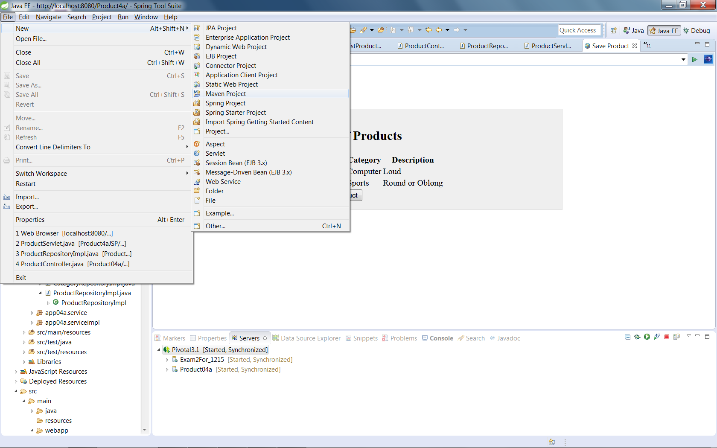

Check create a simple project (Skip archetype selection)

Click NEXT

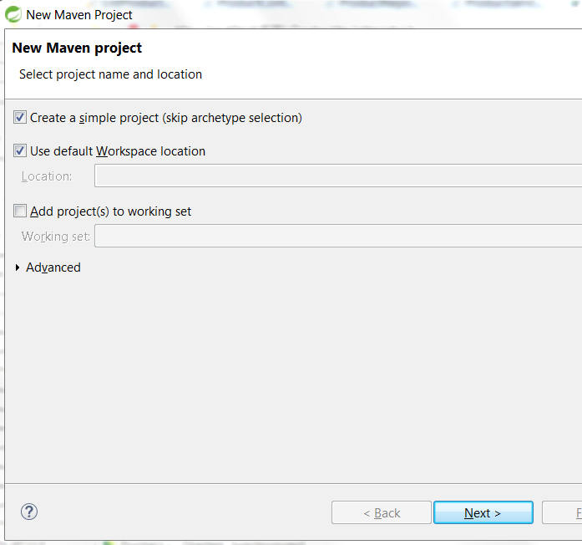

Fill in Group Id

Fill in Artifact Id

Choose WAR packaging

Click Finish

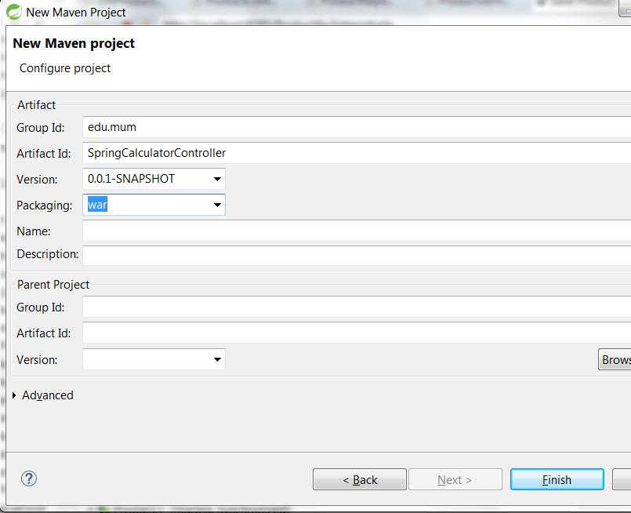

Project structure:

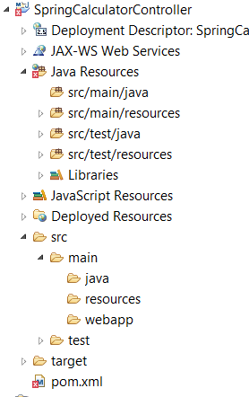

NOTICE:

* 1. Project name is Artifact Id
  2. There is a folder under src/main called webapp. This used instead of

WebContent

* 1. There is pom.xml for the Maven dependencies
  2. You can copy the pom.xml from the demo Produc4a to get started. **If you do THAT be sure to change the Group Id & Artifact Id to reflect your project**

Here is the Product4a structure form reference:

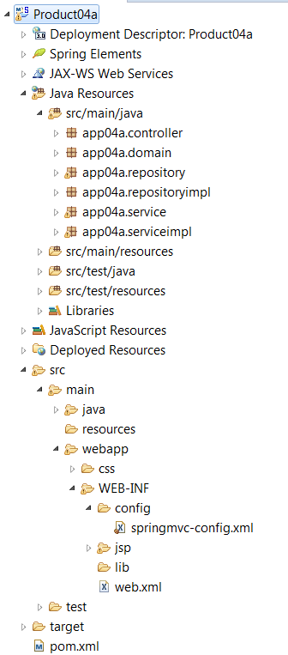

In STS/Eclipse under Window/preferences/Maven. Make sure that your preferences look like this:

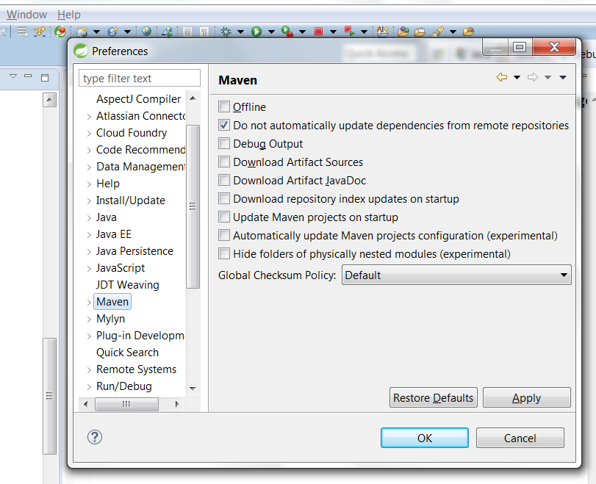

When you have your “project organized/ready”… do this to update your project to Maven:

[Right click project, choose Maven/Update Project…

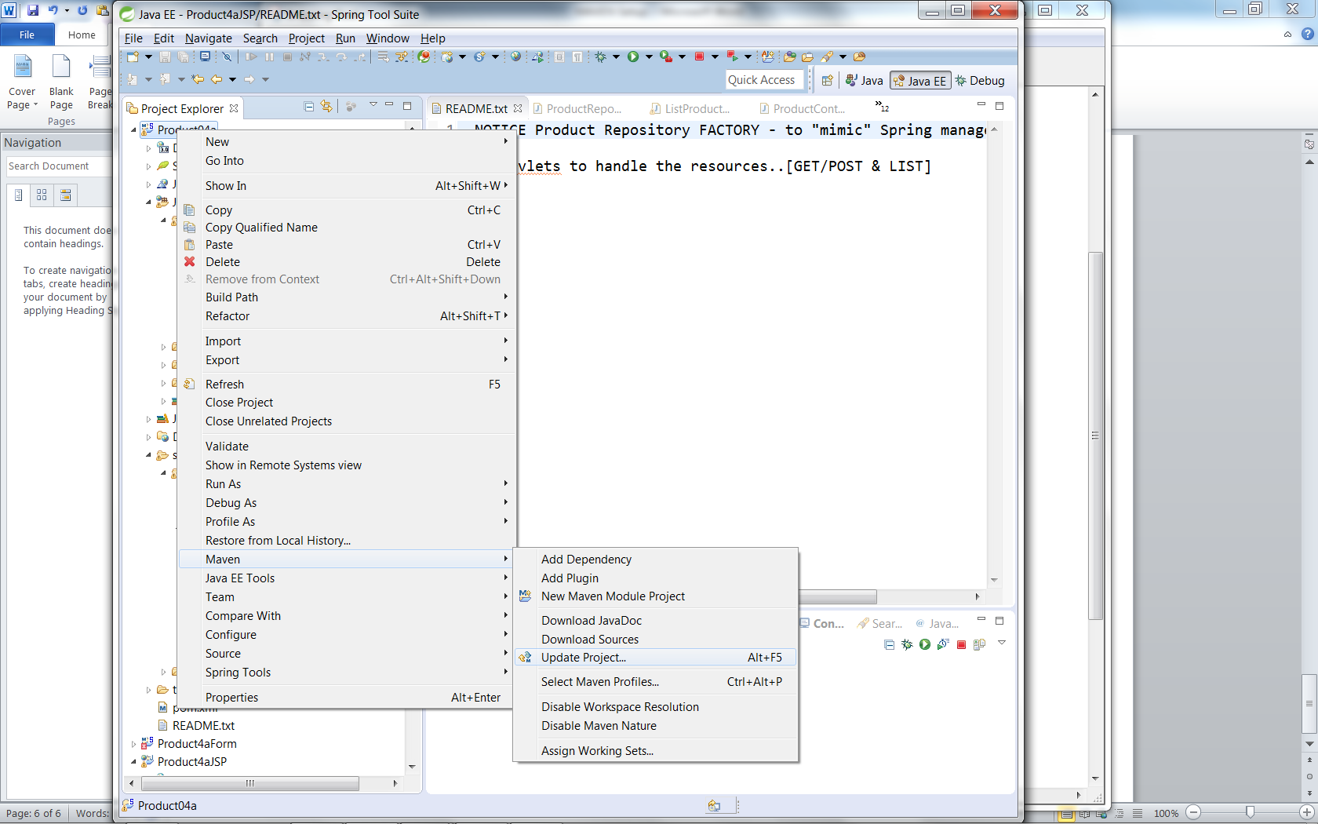

Click OK

